https://www.youtube.com/watch?v=mluS8ovuBKg
- Am I using a optimized , scalable and cost optimized way for deploying the azure resources
- Configuration as a starting point
- Right foundational
- ARM JSON Templates – declarative
- Start small and expand or go at enterprise level
- It can be done with either blue prints or terraform
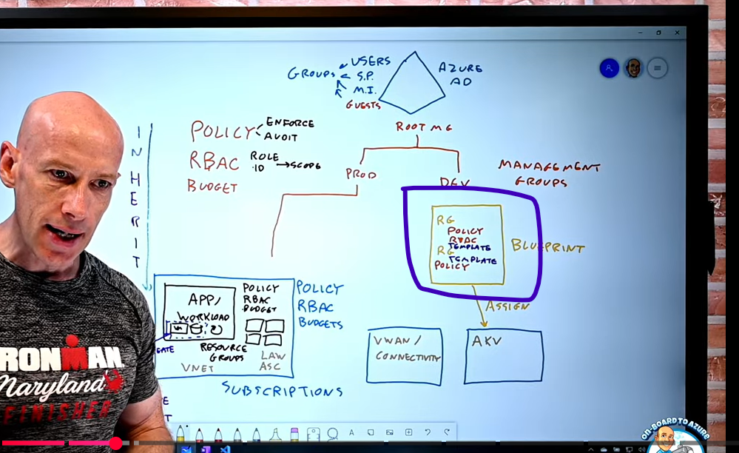

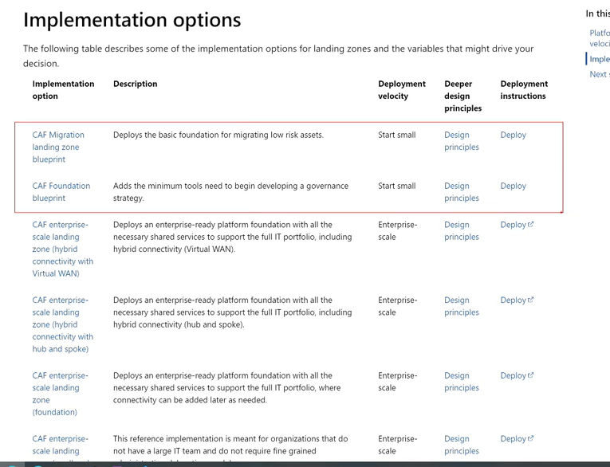

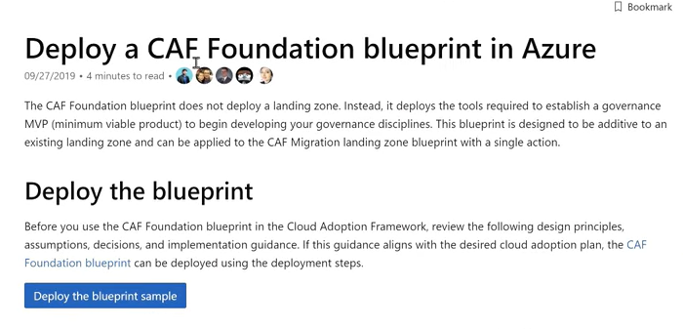
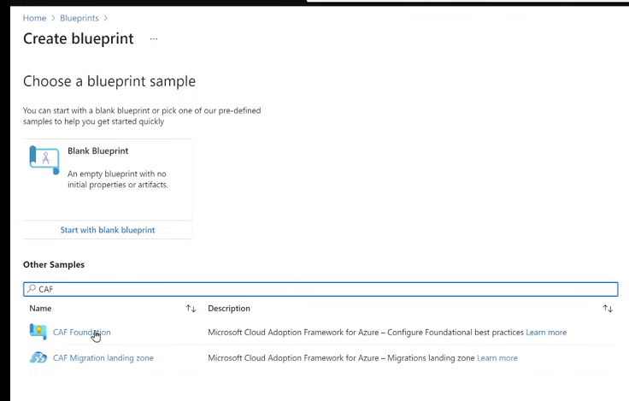
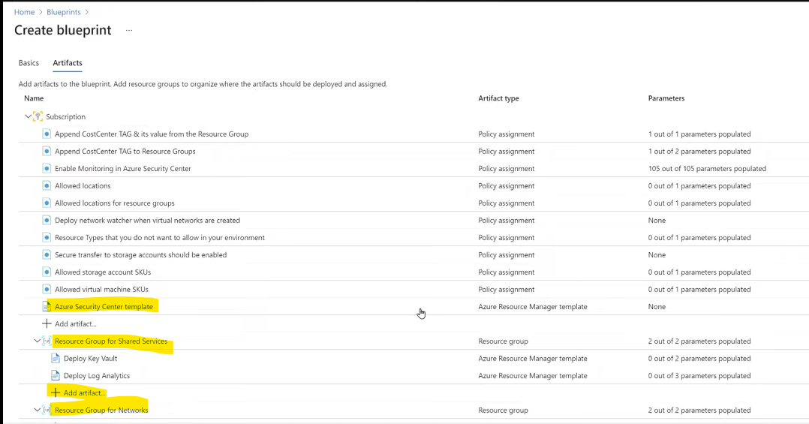
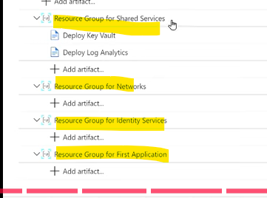
- Enterprise level is mostly done with ARM templates
